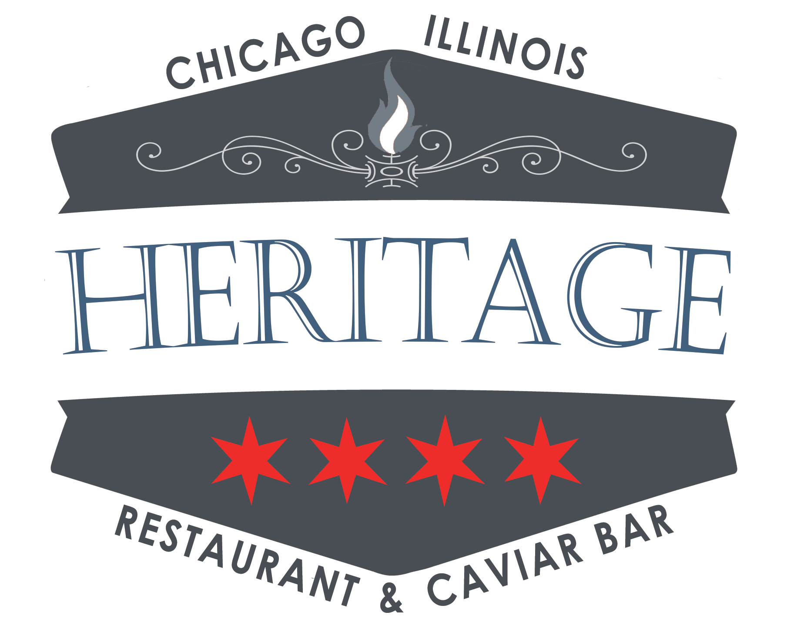

OUR PLACE IS YOUR PLACE.

Book Heritage Restaurant & Caviar Bar for your next celebration!
From black tie to black t-shirt, we welcome private parties for a diverse range of corporate gatherings, boozy birthdays, show-off tastings and swanky soirees. Our first floor can accommodate 45 for a seated meal or a reception style event and The Parlour (lower level) can accommodate 30 seated and 45 for mixing and mingling. Want the whole place to yourself? Full buyout options for 99 people can afford you and yours exclusive access to Heritage Restaurant & Caviar Bar and a customized menu, like our “Caviar Wine Tasting” or “The Zakuski” package.
THE ZAKUSKI PACKAGE
Zakuski is a term for hot and cold hors d’oeuvres intended to follow each shot of vodka. Its literal translation means “something to bite after”
Sample Hors d’oeuvres
$3 per Guest:
Deviled Duck Eggs- Bacon, Smoked Paprika
Puffed Chicharron- Bowfin Caviar, Crème Fraiche
Borscht Shooter – Dill, Apple

$4 per Guest:
Whitefish Crudo– Cilantro, Radish, Celery, Roe
Polish Sausage – House Mustard, Sauerkraut, Pretzel
Cauliflower Crostini – Sourdough, Pickled Raisins, Serrano Yogurt, Herbs

$5 per Guest:
Duck Meatballs – Coconut Broth, Fried Noodles, Cilantro
Sweet Potato Bulgogi – Steam Bun, Kimchi, Fried Shallot
Fried Shrimp Pelmeni – Caraway Aioli, Pickled Beets

House Infused Vodkas:
Seasonal & Rotating Selections
6 oz Bottle $24 / 12 oz Bottle $45 / 24 oz Bottle $85

CAVIAR & SEAFOOD BAR
SMOKED / PICKLED / CURED / PRESERVED
Seasonal Rotating Creations
All Served with house made Black Bread, Kennebec Potato Chips, & Pickles
*choices subsequent to change*

Beet Cured Gravlox – Fermented Eggplant, Apples, Blossoms
Smoked Trout Dip– Togarashi, Lime, Shishito
Pickled Herring – Beets, Dill, Crème Fraiche

Small Platter
Serves 2-6
Medium Platter
Serves 7-12
Large Platter
Serves 12-25
OYSTERS
East Coast / West Coast / South / Neighbors to the North
Rotating Seasonal. House made Garnishes of Sea Salt Matzo, Beet Cocktail Sauce, Giardiniera Mignonette & Hot Sauce
*Order by ½ Dozen*

THE CAVIAR BAR

Traditional garnishes, house made Kennebec potato, black bread & pickles.

*All Caviar is served in 30 gram format. Larger Formats Available upon Request only. Chef Guy also has a few private reserve Caviars that are available on a limited basis*

GOLD OSETRA (acipenser gueldenstaedtii) | ROYAL BELGIAN
Light Amber, Subtle, Walnuts and Cream. 205
POLANCO SIBERIAN RESERVE (acipenser baerii) | URUGUAY
Rich, Nutty, Amazing Pop. 110
OSETRA MALOSSOL (acipenser schrenckii, huso dauricus hybrid) | CHINA
House Favorite, Large Green Egg, Nutty, Clean, Cheesy. 195
IMPERIAL SIBERIAN (acipenser schrenckii) | GERMANY
Highly Aromatic, Elegant, Bold Flavor. 125
IMPERIAL WHITE STURGEON (acipenser transmontanus | USA
Very Rare Golden Color, Large Firm Sized Eggs, Smooth Buttery & Nutty Finish 130
HERITAGE PRIVATE LABEL YELLOW KALUGA (huso dauricus / schrenki) | USA
Large, Bright Green / Yellow Eggs, with a Rich, Creamy Yet Bright Finish. 100
CLASSIC WHITE STURGEON | USA
Medium Sized Rich Brown-Black Eggs, Creamy Yet Clean Finish. 65
HACKLEBACK | WILD TENNESSEE
Rich, Wild Flavor, Petite Eggs, Crisp Texture, Mild, Sweet. 85
RAINBOW TROUT ROE | WILD WASHINGTON
Petite, Red Roe With a Distinct Pop, Sweet, Flavorful, Mild. 30
GOLDEN WHITEFISH | WILD MICHIGAN
Dramatic Color, Firm Popping Texture, Mild, Pleasing. 20
BOW FIN “CHOUPIQUE” | WILD LOUISIANA
Low Price, High Quality, Ancient and Robust. 20
PEARLS d’ESCARGOT | POLAND
Large White Pearls, Light Onion Flavor, Large pop. 80

HERITAGE BUFFET OR FAMILY STYLE CHRISTMAS OPTIONS

Winter Relish Tray
Banchan of House Pickles and Kimchi
Sage and Brown Butter Roasted Rutabaga
Apple-Brussels Slaw with Bacon, and Baby Turnips
Chestnut and Oyster Dressing
Pickled Okra
Braunschweiger with Pickles, Cherry Mustard, and Pullman
Lamb Heart Pierogi, Crispy Onions, Roasted Onions, and Sour Cream
Whipped Potato with Bone Marrow and Roasted Wild Onions
Baked Sweet Potato Casserole with Candied Pecans
Whole Roasted Goose or Turkey with Whiskey- Ginger Gravy
Prime Rib of Beef with Horseradish- Beef Fat Popovers
Wild Cranberry and Cara Cara Orange Marmalade
Plum Pudding with Apricots and Chocolate
Bouche De Noel with Candied Cranberries, Peppermint Ice Cream
Baked Alaska with Seasonal Ice Cream and Textures

HERITAGE SEATED DINNERS
Chef’s Three Course Prix Fix
$40 Per Guest

First Course:
Genesis Growers Green Salad – Hazelnuts, Cranberry-Rosemary Dressing, Pepato
-or-
Radish & Butter – House Butter, Crème Fraiche, Rye Crumble, Beet Gel

Second Course:
Mackinaw Lake Trout – Butternut Squash, Apples, Black Garlic, Kale, Sage
-or-
Wood Grilled Hanger Steak – Celery Root-Horseradish Gratin, Brussels Sprouts, Sauerkraut
-or-
Wood Grilled Cauliflower – Palm Sugar Glaze, House Kimchi, Puffed Rice, Radish
-or-
Smoked Chicken Cassoulet- Cranberry Beans, Apple Cider, Root Vegetables, Sourdough, Beer Mustard

Third Course:
Pumpkin Cheesecake, Coffee Ice Cream, Roasted White Chocolate
-or-
Daily Pie & Ice Cream – Seasonal & Rotating

Chefs Four Course Prix Fix “Tour of Cuisine”
$60 per Guest Family Style

First Course:
Beet Gravlax – Summer Eggplant, Apples, Fresh Herbs
Pickled Herring – Beets, Crème Fraiche, Dill

Second Course:
Potato and Cottage Cheese Pierogi – Cherry, Mustard Seed Crème Fraiche
Lamb Mandu- Crispy Rice Dumplings, Scallions, Ramp Aioli

Third Course:

Hamachi Collar - Nam Prik, Palm Sugar, Puffed Rice
Fried Chicken Salad - Grilled Rapini, Cabbage, Radish,
Soy Sprouts, Kimchi - Lime Vinaigrette.

Fourth Course:
Dark Chocolate Souffle with Sesame Ice Cream

Chefs Five Course Prix Fix
$130 per Guest

Amuse Bouche:
Cauliflower Panna Cotta – Hackleback, Radish, Cucumber, Dill
First Course:
Potato and Dill Soup
Whipped Ham Croquette, Bowfin
Or
Roasted Beet Salad
Cottage Cheese and Horseradish, Orange, Olive Oil Pearl

Second Course
Baked Alaskan King Crab Legs
Tobiko Aioli, Grilled Lemon
Or
Wood Grilled 1871 Oysters “Heritage”
Quail Egg, Pearls d’ Escargot, Creamed Greens

Third Course

Wood Smoked Half Duck
Czech Dumplings, Purple Sauerkraut, Giblet Gravy, Root Vegetable
Or
Goose Cassoulet
Roasted Breast, Sausage, Confit Leg, Roasted Apple, Sourdough
Or
Wood Grilled Cauliflower – Palm Sugar Glaze, House Kimchi, Puffed Rice, Radish

Fourth Course:
Apple Brown Betty with Ginger Ice Cream
-or-
Daily Pie & Ice Cream – Seasonal & Rotating

LUNCH
DROP OFF / PICK UP
SALADS:
Small $ 12 / Medium $22 / Large $28
Genesis Growers Green Salad – Garden Herbs & Blossoms, Lemon-Rosemary Dressing, Pepato
Heritage Miso Caesar Salad – Red Leaf, Rye Croutons, Pecorino Pickled Pearl Onion
Roasted Beet Salad – Horseradish Cheese, Caraway, Oranges, Turnips, Pea Tendrils.

SANDWICH PLATTERS
Small $ 18 / Medium $36 / Large $52
Braunschweiger – House Pullman Loaf, Bread ‘n’ Butter Pickles, Onion, Mustard
BLT – Ciabatta, Lamb Bacon, Pickled Green Tomato Relish, Red Veined Mustard Greens
Vegan Muffuletta – Beet Hummus, Grilled Eggplant, Green Peach Tapenade, Arugula
Grilled Hanger Steak – Horseradish Aioli, 4 year Cheddar, Arugula, Ash Baked Onions

DESSERT PLATTERS
Small $ 12 / Medium $22 / Large $40
Cookies, Brownies, Seasonal Rotating Pastries
LUNCH BOXES
One Sandwich, Chips & a Cookie $10
Half of a Sandwich, 1 Salad, & a Cookie or Chips $12

BRUNCH

DROP OFF / PICK UP

SEASONAL PASTRIES
One Dozen Doughnuts $48
One Dozen Kolachki $48
Coffee Cake $20

SIDE PLATTERS
Small $ 18 / Large $30
Scrambled Genesis Growers Eggs
Roasted Red Potatoes – Ash Baked Onions, Herbs
Blackened Maple Bacon
House Cheddar Bratwurst
Genesis Growers Green Salad – Garden Herbs & Blossoms, Lemon-Rosemary Dressing, Pepato

RATES / CANCELATIONS / POLICIES

Our policy is to take a credit card for %75 of the event as a deposit.
Then the day of the remaining will be charged plus any a la carte day of purchases.

Guest Count. Minimum is due upon deposit. That is what we base the deposit on. Then actual guest count is due five days before the event.
Cancelations are applicable up to 14 days in advance. Anything after 14 days can be used towards rescheduling a future event.

